|  |  |  |
| --- | --- | --- |
|  |  |  |
|  |  |  |
|  |  | |  | | --- | |  | | Challenge Title | : | Project Build-A-Thon | | Project ID | : | SPS_PRO_2846 | | Project Title | : | IBM Cognos Powered Hr and People Analytics Dashboard | | Duration | : | 4.5 Days | | Name | : | A S Haritha |   Name of College : St.Ann’s College for Women |

**Abstract**

HR analytics is a data-driven method of improving decisions that impact HR functions. It requires Proper data collection tools with successful metrics strategies like quality, quantity, time ,cost of money, customer satisfaction, etc,. The main aim of this project is to learn and implement data analysis tools of IBM - IBM Cognos Analytics with Watson and prepare graphical visualization of data at an ease to create meaningful dashboards. These Metrics are simple way to quantify, measure and track key performance indicators.IBM Cognos Analytics is useful for creating Dashboards and scorecards for Hr Metrics too.This helps in making and supporting decisions taken for running any organization successfully.

**Project Objectives**

The following are the main objectives of this project,

* Know fundamental concepts and can work on IBM Cognos Analytics.
* Gain a broad understanding of plotting different graphs.
* Able to create meaningful dashboards

**Prerequisite Courses and Uploading the Skill badges.**

* As a mandatory step, we need to complete the courses mentioned in the course section and upload the skill badge or certificate for verification.

###### Getting Started With Cloud For The Enterprise

This course covers the basic foundations of the cloud for the enterprise.

###### Getting Started With Enterprise Data Science

This course provides a basic understanding of the foundations of Data Science.

**IBM Cognos Powered Hr And People Analytics Dashboard**

Category : IBM Cloud Application

Skills Required: IBM Cloud

Project Description:

Analytics is the interpretation of data patterns that assist decision-making and performance improvement. HR analytics is defined as the process of measuring the impact of HR metrics, such as time to hire and retention rate on business performance.In this project, we visualize, analyze and gain most of the insights by creating a dashboard.

**Solution Requirements:**

Service Used: IBM Cognos Analytics.

**Project Flow :**

* Users create multiple analysis graphs/charts.
* Using the analyzed chart creation of Dashboard is done.
* Saving and Visualizing the final dashboard in the IBM Cognos Analytics.

To accomplish this, we have to complete all the activities and tasks listed below

* IBM Cloud Account
* Log in to Cognos Analytics
* Working with the Dataset
  + Understand the Dataset
  + Loading the Dataset
* Data visualization charts

**IBM Cloud Account:**

We start the project by creating IBM Cloud account. We need to watch the video provided and follow the steps.Then we need to create IBM Cognos account using the link provided.

IBM Cognos Analytics integrates reporting, modelling, analysis, dashboards, stories, and event management so that you can understand your organization's data, and make effective business decisions.

**IBM Cognos Analytics with Watson:**

**Upload data:**

Upload or drag and drop the spreadsheets, csv files and other data sources.

**Prepare data:**

Use data modules to clean and connect data from multiple resources.

**Exploration :**

Quickly find unbiased answers by identifying trends in your data with data exploration

**Present data:**

Create sophisticated, multi-page, multi-query dashboards ,reports or stories.

**Working With The Dataset**

In this part of our project, we need to download the dataset and understand the dataset.

**Understand the dataset**:

This project is based on an understanding of the HR analytics dataset. It has 1470 data points (rows) and 36 features (columns) describing each HR analytics related details

Let’s understand the data we’re working with and give a brief overview of what each feature represents or should represent

1. Age- Age of employees
2. TotalWorkingYears – Total number of years employee worked
3. Attrition – Possibility of staying/leaving the company
4. YearsAtCompany - Number of years worked at that company
5. MonthlyIncome – Monthly salary
6. JobRole – Type of job
7. YearsInCurrentRole – Number of years in holding the position
8. YearsSinceLastPromotion – Last dated promotion
9. YearsWithCurrManager – number of years worked with the current manager
10. NumCompaniesWorked – Number of companies worked

### Loading The Dataset

Now we need to download the dataset file and upload it in the IBM Cognos and work futher on it. We can watch the videos provided and work on the file accordingly. This is the file we worked with.



**Data Visualization Charts**

Using the HR Analytics dataset, we create various graphs and charts to highlight insights and visualizations.

### Analysing Age, Total Working Years, Attrition, Years At Company And Monthly Income :

Analysing various fields like Age, TotalWorkingYears, Attrition#, YearsAtCompany and MonthlyIncome by taking the average values.

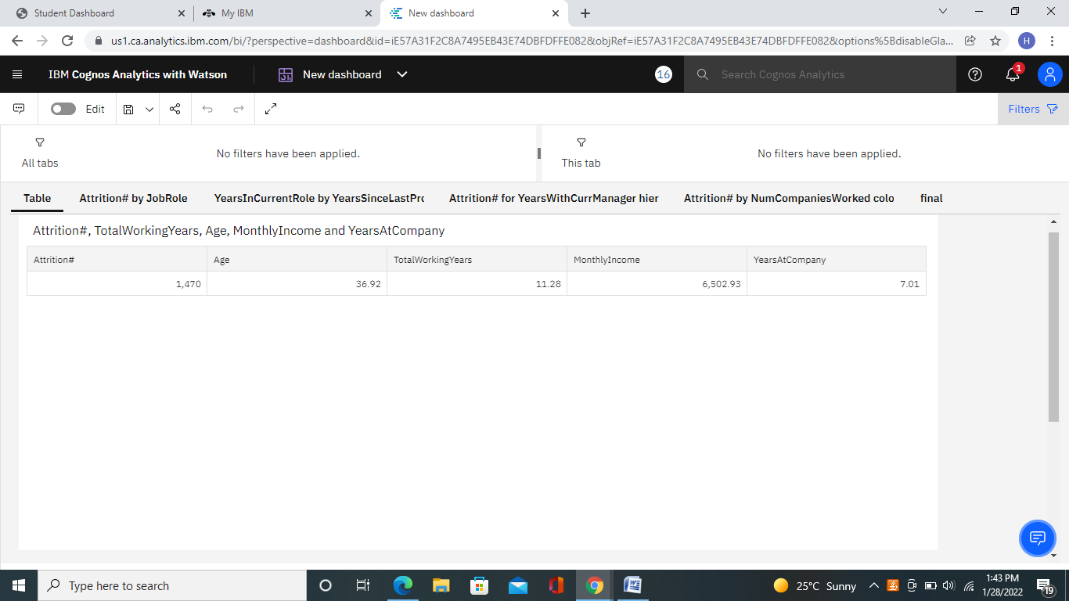

### Analysis Of Attrition By Job Role :

Here, we visualize attrition with respect to job role as a bar chart and analyze the chart.

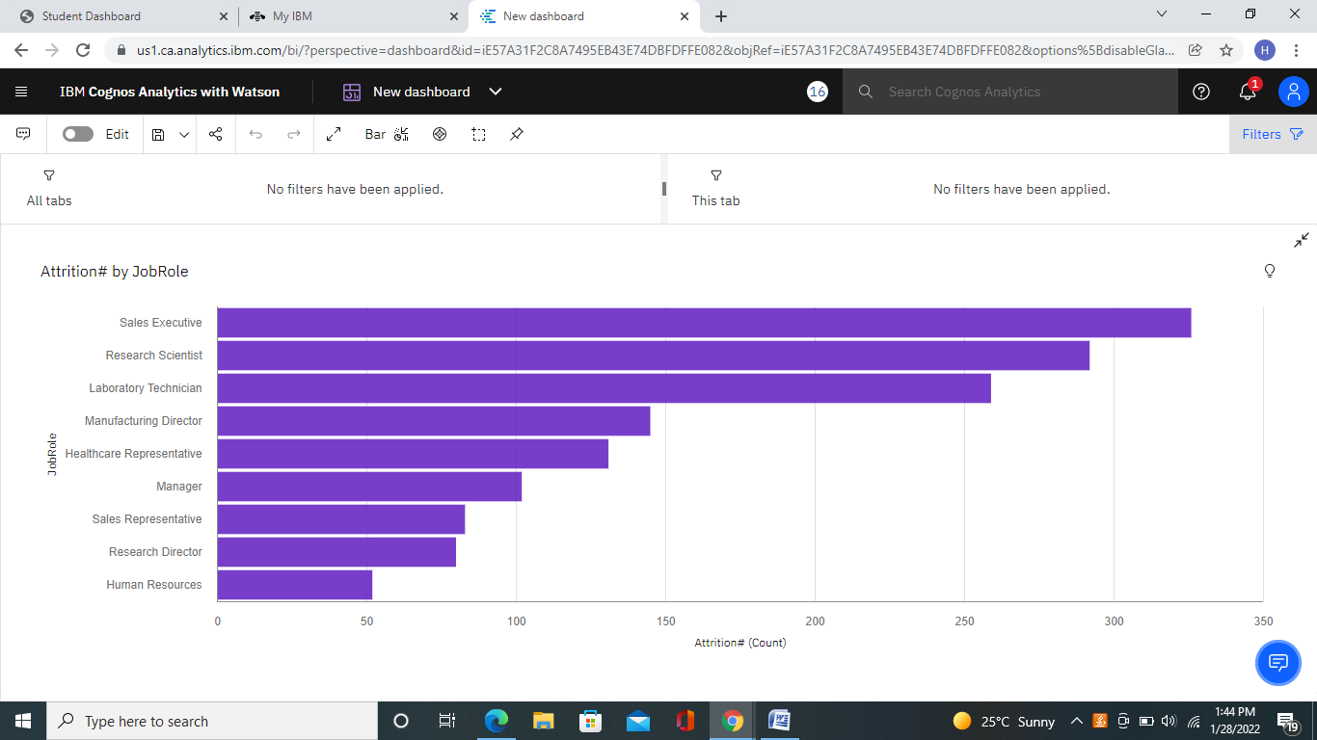

### Years In Current Role By Years Since Last Promotion Colored By Attrition :

Here, we visualize a point chart with YearsSinceLastPromotion on x-axis and Average of YearsInCurrentRole on y-axis. We also differentiated the points with respect to Attrition.

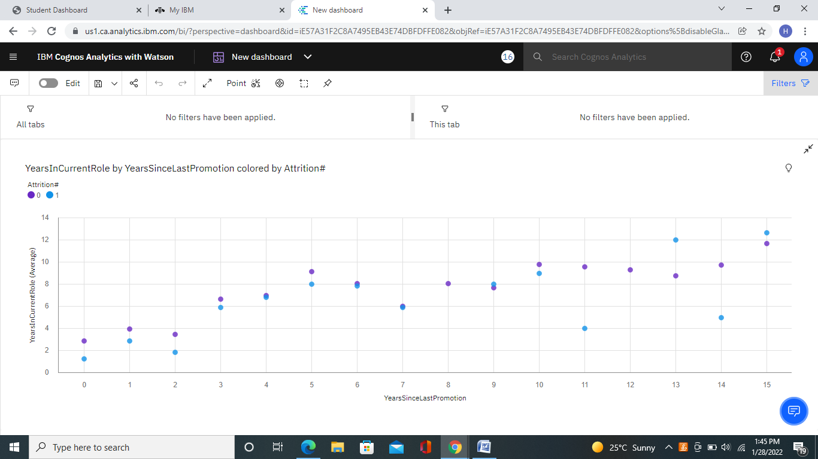

**Attrition For Years With Current Manager Hierarchy :**

Here, we create a treemap representing YearsWithCurrManager and Attrition# and analyze the dataset

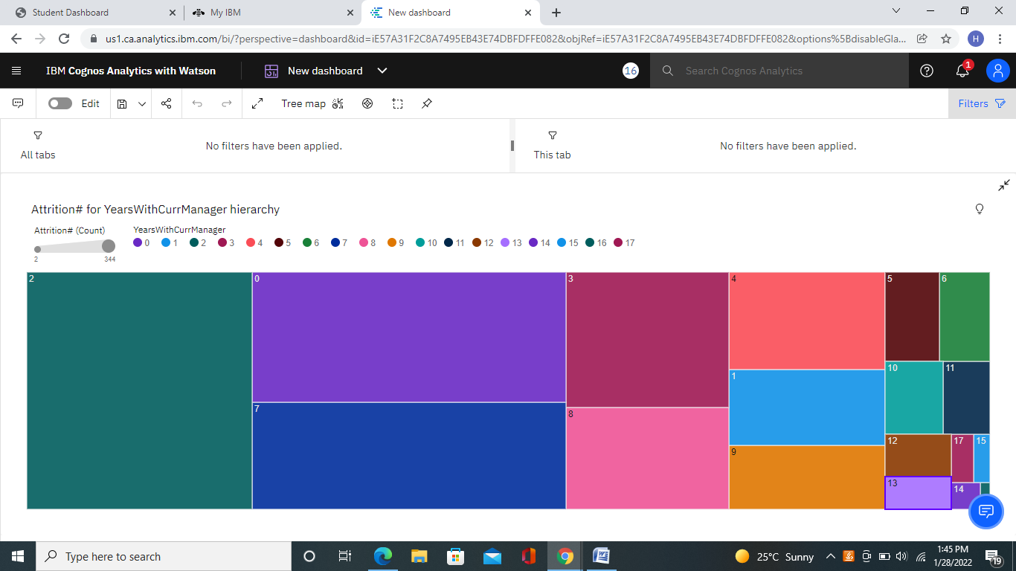

**Attrition By No Of Companies Worked Colored By JobRole :**

Here, we visualize using area chart representing NumCompaniesWorked and Attrition. We also differentiated the areas with respect to the job role.

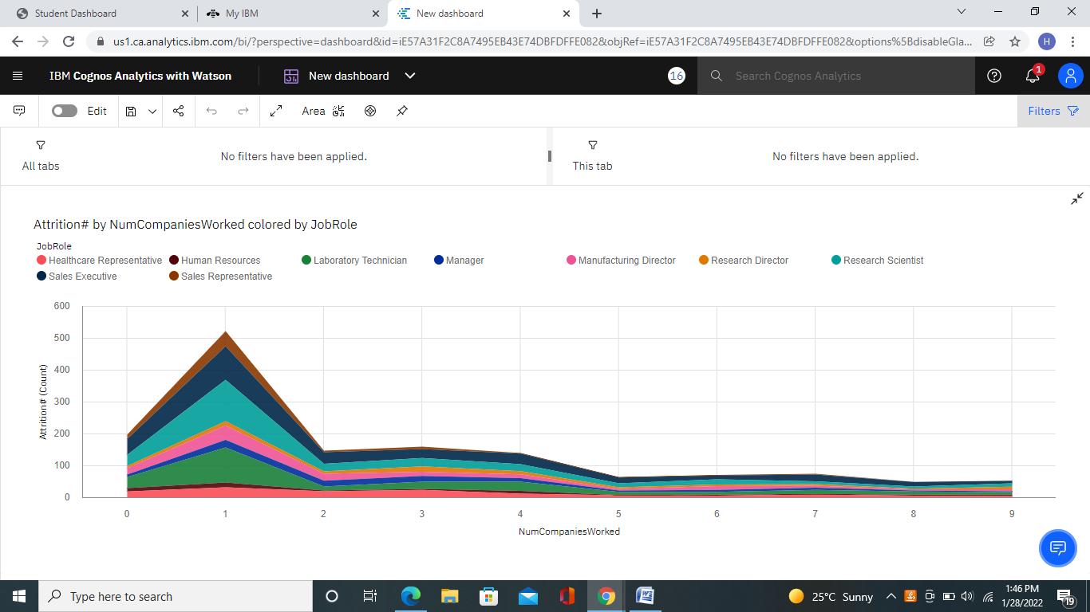

**Create The Dashboard**

Once we’ve created views on different tabs in Cognos analytics, you can pull them into a dashboard.

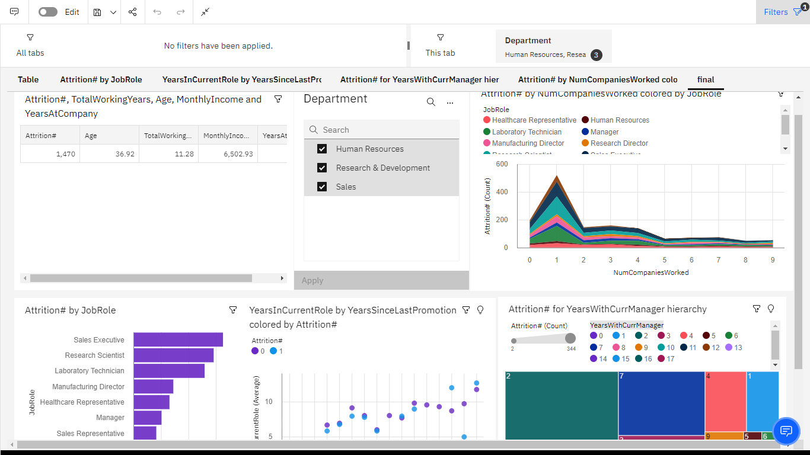

**Export The Analytics**

Finally, its to share your work either through email/link/pdf to showcase your works to others.

|  |  |  |  |  |
| --- | --- | --- | --- | --- |
| |  | | --- | |  | |  |  |  |
| |  | | --- | | https://mail.google.com/mail/u/0/images/cleardot.gif | | | |

<https://us1.ca.analytics.ibm.com/bi/?perspective=dashboard&pathRef=.my_folders%2FNew%2Bdashboard&action=view&mode=dashboard&subView=model0000017e964502ab_00000000>

https://us1.ca.analytics.ibm.com/bi/?perspective=dashboard&pathRef=.my_folders%2FNew%2Bdashboard&action=view&mode=dashboard&subView=model0000017e9637121a_00000000

**Conclusions**

|  |
| --- |
| Getting Started with Cloud for the Enterprise  Issuer: IBM |

<https://www.credly.com/go/CzzzhwdXSP5HuG2vdK3YxA>



Getting Started with Enterprise Data Science  
Issuer: IBM

<https://www.credly.com/go/Qn03d4dO73pzAp6HOaMwJA>



**Output of the dataset in IBM Cognos Analytics:**



|  |
| --- |
| Getting  Issuer: IBM |

[View Details](https://www.credly.com/go/Qn03d4dO73pzAp6HOaMwJA)